MACH4METAL

Metalworking machinery
Transito 21,
6909 DA BABBERICH
Netherlands
Tel. +31 (0)316 – 247123
Fax. +31 (0)316 - 247956
info@mach4metal.com
www.mach4metal.com

Account No: 66.52.13.883
IBAN : NL33 INGB 0665 2138 83
BIC : INGBNL2A

LGB Portal Grinder 1730 x 930 x 550
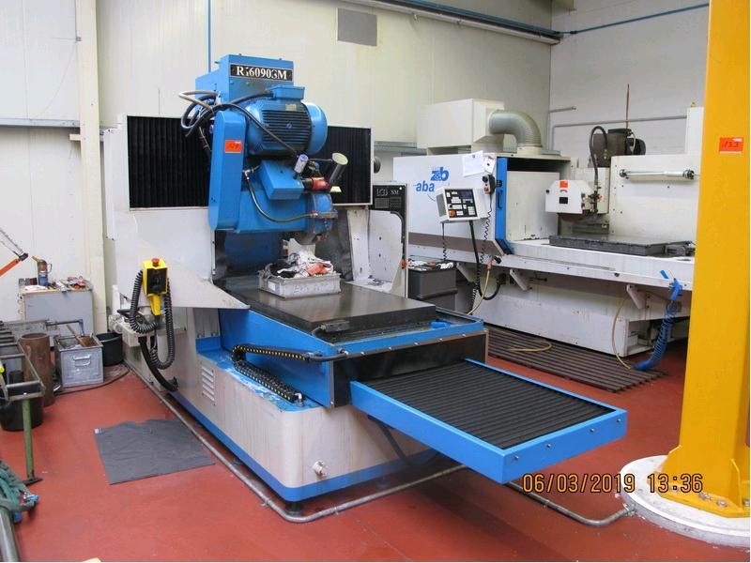
- Make : LGB France
- Type : R 16090 SM
- Serial :
- Age : 1998

- Capacity / Working area

- X Travel : 1.730
- Y Travel : 930
- Z Travel : 550
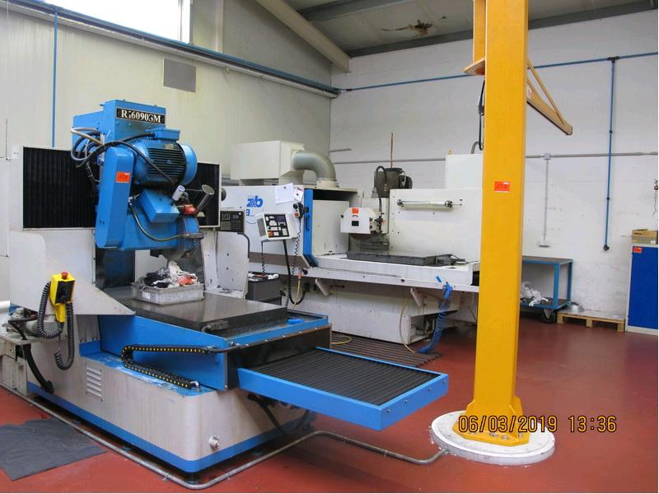
- Magnet table length : 1.600
- Magnet table width : 800
- Table work load : 2.000
- Distance Table – Stone : 600

- Table speed : 0 – 25.000 mm /M
- Cross feed : 1.000 mm/M
- Stone : Ø 400 X 60 X 127

- Quick vertical movement : 5 – 500 mm/M
- Slow vertical movement : 0,4 – 4 mm/M
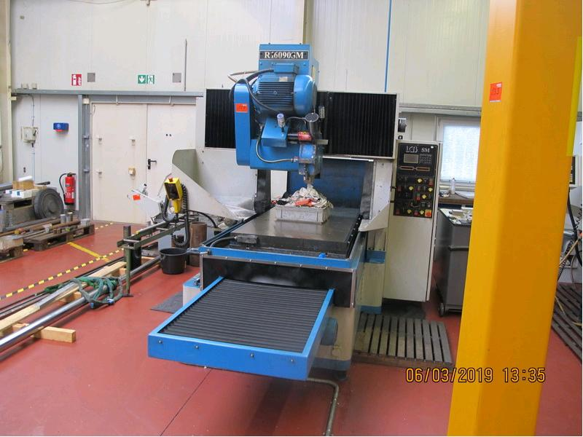

- Dimensions
- Length : 4.160
- Width : 2.215
- Height : 2.500
- Weight : 7.500

Please Note: The above information has been obtained to the best of our ability and belief from, and from the manufacturers where possible. It is given in good faith, but its accuracy can not be guaranteed. Accordingly, it will not form a representation or constitute contractual terms. We advise you to check any vital details

